Import Data Using Transform Maps(spreadsheet)
Project Documentation Phase
Project Overview

The project titled “Import Data using Transform Maps (Spreadsheet)” demonstrates how data from an Excel spreadsheet can be imported into the Service now platform using Import Sets and Transform Maps.

The project starts with preparing structured data in an Excel spreadsheet. The spreadsheet is uploaded into Service now through an Import Set. The imported data is temporarily stored in an Import Set Table. A Transform Map is then created to transfer the source data into the appropriate fields of the target Service now table.

The complete process helps reduce manual data entry and provides an organized method for importing external spreadsheet data into Service Now.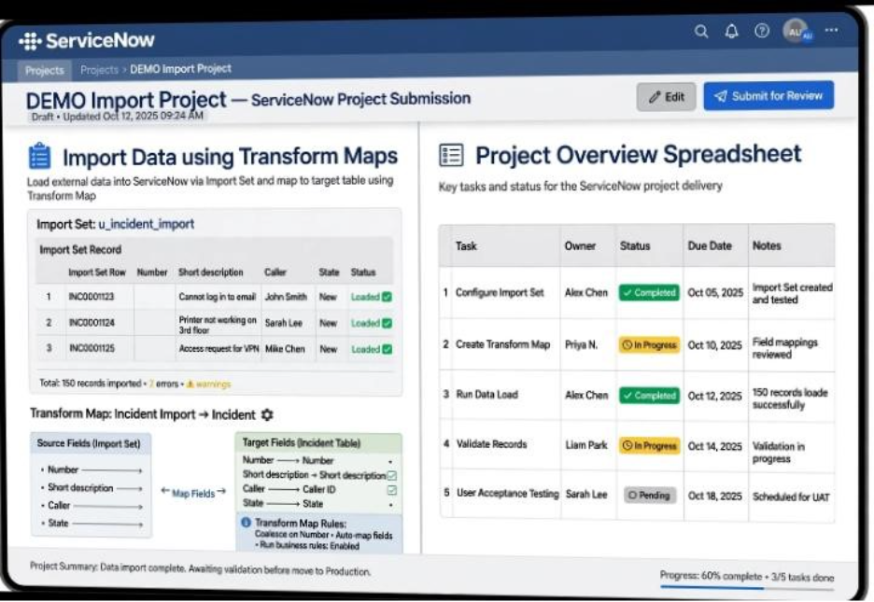

Project Objectives

The main objectives of the project are:

- To import Excel spreadsheet data into Service now.
- To create an Import Set for loading the spreadsheet data.
- To create a Transform Map for transferring the imported data.
- To map source fields with the corresponding target fields.
- To execute the transformation process successfully.
- To verify the imported records in the target table.
- To reduce manual data entry.
- To improve the accuracy and efficiency of the data import process.

Technologies Used

The following tools and technologies are used in the project:

- Technology / Tool| Purpose
- Service now| Platform used for importing and managing data
- Import Set| Used to load spreadsheet data into Service now
- Transform Map| Used to transfer and map source data to the target table
- Microsoft Excel| Used to prepare the input data
- Web Browser| Used to access the Service now instance
- Internet Connection| Required to access the Service now platform.

Implementation Steps

The project is implemented through the following steps:

Step 1: Prepare the Excel Spreadsheet
The required data is entered into an Excel spreadsheet with proper column headings and records.

Step 2: Validate the Data
The spreadsheet is checked for incorrect values, duplicate records, blank rows, and formatting issues.

Step 3: Create the Import Set
An Import Set is created in Service now to load the Excel spreadsheet data.

Step 4: Upload the Spreadsheet
The prepared Excel file is uploaded into Service now. The data is loaded into the Import Set Table.
Step 5: Create the Transform Map
A Transform Map is created between the Import Set Table and the selected target table.

Step 6: Map the Fields
The source fields are mapped to the corresponding target fields

Example:
- Employee Name → User1, User 2, User 3, User 4, User 5, User 6
- Employee ID → SB0001, SB0002, SB0003, SB0004, SB0005, SB0006
- Email→ user1@gmail.com, user2@gmail.com, user3@gmail.com , user5@gmail.com, user6@gmail.com
Department → Service Now, Service Now, Service Now, Service Now, Salesforce, Salesforce
Location -> Tamil Nadu, Tamil Nadu, Tamil Nadu, Tamil Nadu, Tamil Nadu, Tamil Nadu,

Step 7: Run the Transform
The Transform Map is executed to transfer the data from the Import Set Table to the target table.

Step 8: Verify the Output
The target table is checked to confirm that the imported records and field values are cos transformation Configuration Details.
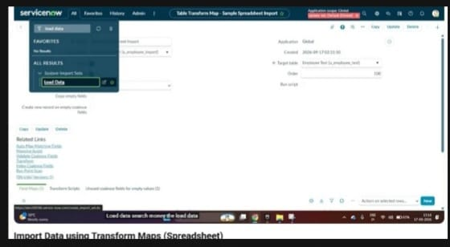

Configuration Details

The project configuration consists of an Import Set, Import Set Table, Transform Map, source fields, target fields, and the target Service now table.

The Import Set is used to receive the Excel data. The Transform Map defines the relationship between the source data and the target table. Field mappings determine where each source value should be stored in the target table.

Proper configuration of these components is important for successful data transformation
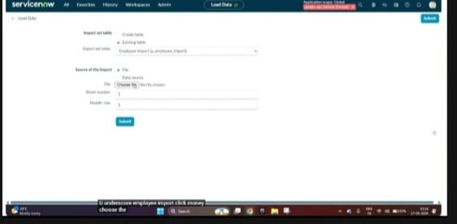

Screenshots and Evidence

Screenshots are included in the documentation to provide evidence of the project implementation.

The following screenshots can be added:

1. Excel Spreadsheet – Shows the original source data.
2. Import Set – Shows the Import Set configuration.
3. Imported Data – Shows the records loaded into the Import Set Table.
4. Transform Map – Shows the created Transform Map.
5. Field Mapping – Shows the source and target field mappings.
6. Transform Results – Shows the transformation result.
7. Final Target Table – Shows the successfully imported records.
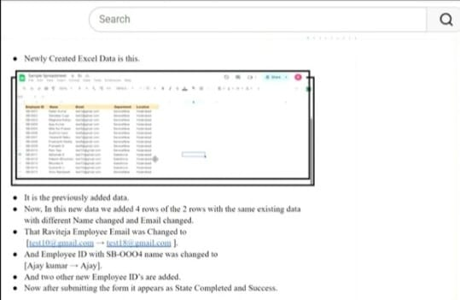

Example:

- Excel Spreadsheet Containing Source Data
- Import Set Configuration
- Transform Map Configuration
- Source-to-Target Field Mapping
- Final Imported Records
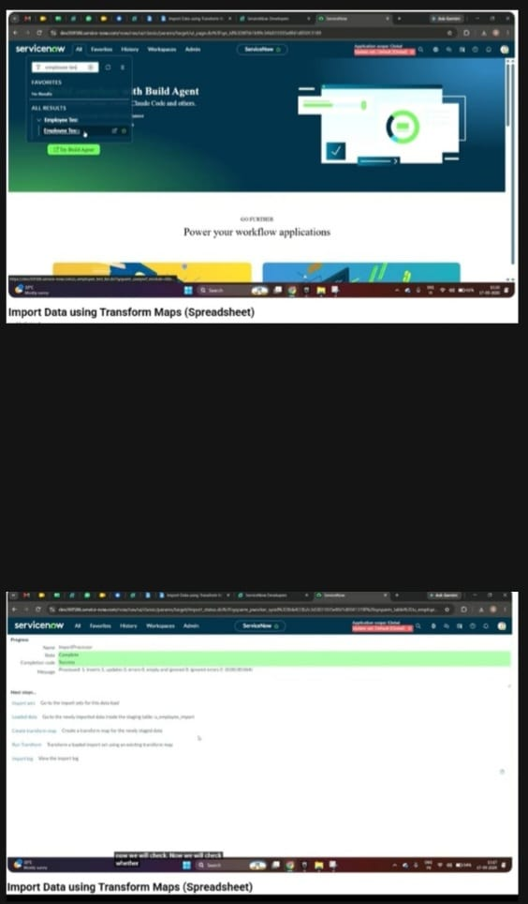

Result and Output

The project successfully demonstrates the import of spreadsheet data into Service now using Import Sets and Transform Maps.

The source data from the Excel spreadsheet is loaded into Service now, mapped to the appropriate target fields, transformed, and stored in the target table.

The final output is verified by comparing the imported records with the original spreadsheet data. This confirms that the data has been transferred correctly

Challenges Faced

During the project implementation, some challenges may occur such as:

- Incorrect Source to -target filed mapping.
- Incorrect data formats in the spread sheet
- Missing or empty values.
- Duplicate records.
- Transformation errors.
- Differences between spreadsheet field names and Service now field names.

These issues can affect the accuracy of the imported data.

Solutions Implemented

The identified issues are resolved by carefully checking the spreadsheet data and Service now configuration.

The following solutions are applied:
- Verify the Excel data before uploading.
- Remove unnecessary blank rows and duplicate records.
- Check the source and target field mappings.
- Ensure that the data format matches the target fields.
- Review the Import Set and Transform Map results.
- Correct errors and run the transformation again.
- Verify the final records in the target table.

Conclusion

The project successfully demonstrates the process of importing data from an Excel spreadsheet into Service now using Import Sets and Transform Maps.

The project covers spreadsheet preparation, data upload, Import Set creation, Transform Map configuration, field mapping, data transformation, testing, and final verification.

This project provides a simple and systematic method for transferring external spreadsheet data into Service now while reducing manual data entry and improving data management.

Future Enhancements

The project can be enhanced in the future by adding more advanced data validation and transformation features.

Possible enhancements include:

- Automatic validation of spreadsheet data.
- Handling large Excel files efficiently.
- Adding transformation scripts for complex data.
- Implementing duplicate record detection.
- Adding automated error reporting.
- Scheduling regular data imports.
- Supporting additional data sources such as CSV files and external systems.

These enhancements can make the data import process more automated, reliable, and scalable.

